TECHNICAL REPORT

No. 17

WATER SAMPLING IN QUANG NGAI PROVINCE
AND INSTALLATION OF THE DATA LOGGERS
19.10.2012 - 22.10.2012

Author: Hoang Thi Hanh, Hoang Dai Phuc
Date: Ha Noi, October 24th 2012
REPORT FOR WATER SAMPLING IN QUANG NGAI PROVINCE

Field Trip:
Date 19.10.2012 - 22.10.2012
Location: IGPVN monitoring stations, local household, Ve river, Tra Khuc river, wastewater lakes, Bau Lang canal in Quang Ngai province
Participants:
- Hoang Thi Hanh IGPVN project
- Hoang Dai Phuc IGPVN project
- Dao Trong Tu CWRPI
- Nguyen The Chuyen CWRPI
- Nguyen Bien Nhu Son DONRE Quang Ngai
Objectives:
- to check the condition and status of the monitoring wells after flushing
- collect water samples for chemical analysis
- to install the data logger in the monitoring wells
Executed work:
During the 4 day field trip to Quang Ngai province, the working group has visit all the IGPVN monitoring stations (from IGPVN-1 to IGPVN-9) and collected water samples from each monitoring well.
On the other hand, the working group also collected water samples of various types, from five households in Nghia Hanh and Tu Nghia districts; Ve river and Tra Khuc river; the two wastewater lakes (Pham Van Dong and Quang Trung) and Bau Lang canal. The specific locations are shown on the map (Fig. 1). Daily schedule is summarized in Table 1.
At each monitoring station, the water was extracted using a submersible pump MP1 (Grundfos). The extracted water was contained in a 14L plastic bucket. The flow rate was measured by counting the amount of time it takes to fill up the bucket. The required volumes of water to be removed from each well are calculated and shown in Table 2. Some in-situ parameters (Temperature, pH, EC, ORP and DO) were measured using WTW 340i and the results are shown in Table 3.
Fig. 1: Water sampling location in Quang Ngai province
Table 1: Detailed sampling schedule in Quang Ngai province
Date | Location |  |  | Sample collected
 |  | X | Y
19-10-2012 | IGPVN-6 | 262915 | 1673844 | IGPVN-6a
 |  |  |  | IGPVN-6b
 | Pham Van Dong lake | 264523 | 1672943 | WW-01
 | Quang Trung lake | 263900 | 1673753 | WW-02
 | IGPVN-8 | 265018 | 1673303 | IGPVN-8
 | IGPVN-5 | 260325 | 1673432 | IGPVN-5
 | IGPVN-4 | 260102 | 1673094 | IGPVN-4
 | Bau Lang canal | 260358 | 1672989 | WW-03
20-10-2012 | IGPVN-9 | 269437 | 1671603 | IGPVN-9a
 |  |  |  | IGPVN-9b
 | Household tubewell 1 | 272467 | 1670016 | GW-01
21-10-2012 | Household tubewell 2 | 266117 | 1669312 | GW-02
 | Household tubewell 3 | 267473 | 1666723 | GW-03
 | Household tubewell 4 | 265532 | 1661212 | GW-04
 | IGPVN-1 | 261331 | 1664812 | IGPVN-1
 | IGPVN-2 | 271236 | 1665258 | IGPVN-2a
 |  |  |  | IGPVN-2b
 | IGPVN-7 | 261568 | 1670047 | IGPVN-7
 | IGPVN-3 | 257398 | 1672880 | IGPVN-3
 | Ve river | 271390 | 1664522 | SW-01
 |  | 267505 | 1661202 | SW-02
 |  | 264257 | 1657777 | SW-03
 | Tra Khuc river | 258234 | 1675294 | SW-04
 | Bau Lang canal | 259764 | 1672572 | WW-04
22-10-2012 | Tra Khuc river | 268285 | 1674236 | SW-05
 |  | 263837 | 1674972 | SW-06
 |  | 261221 | 1674101 | SW-07
 |  | 261273 | 1673955 | WW-05
 | Household tubewell 5 | 272923 | 1673669 | GW-05
Total |  |  |  | 29 samples

After removing all the stagnant water in the well and the values (pH, EC, ORP) on WTW screen became stable, the working group started to collected water samples. The total sample volume of 4L was contained into two 2L PET cans as recommended by the laboratory in charge. All the PET cans were washed with diluted HNO₃ solution (10%) and rinsed three times with the sample solution before sampling. Groundwater samples from all the monitoring wells and surface water samples were also collected for isotope determination. Water samples after collected were packed into boxes and sent directly to the laboratory (Sac Ky Hai Dang Science Technology Services Joint Stock Company) for chemical analysis.

Table 2: Tentative pumping time calculated for each well
No. | Well ID | Depth (m) | Static water level | H*  (m) | Diameter (m) | Volume (4V) (m³) | Capacity of pump (m³/h) | Pumping time (min)
1 | IGPVN-1 | 36 | 1.98 | 34.02 | 0.045 | 0.865 | 1 | 5 (out)
2 | IGPVN-2a | 15 | 3.6 | 11.4 | 0.045 | 0.290 | 1 | 5 ( out)
3 | IGPVN-2b | 32.5 | 3.86 | 28.64 | 0.045 | 0.728 | 1 | 5 (out)
4 | IGPVN-3 | 16.5 | 4.27 | 12.23 | 0.045 | 0.311 | 1 | 22
5 | IGPVN-4 | 20 | 3.03 | 16.97 | 0.045 | 0.432 | 1 | 27
6 | IGPVN-5 | 14.5 | 2.73 | 11.77 | 0.045 | 0.299 | 1 | 19
7 | IGPVN-6a | 12 | 5.58 | 6.42 | 0.045 | 0.163 | 1 | 15
8 | IGPVN-6b | 29.5 | 5.76 | 23.74 | 0.045 | 0.604 | 1 | 42
9 | IGPVN-7 | 36 | 2.45 | 33.55 | 0.045 | 0.853 | 1 | 52
10 | IGPVN-8 | 30.5 | 5.99 | 24.51 | 0.045 | 0.623 | 1 | 43
11 | IGPVN-9a | 14 | 2.45 | 11.55 | 0.045 | 0.294 | 1 | 18
12 | IGPVN-9b | 31 | 3.07 | 27.93 | 0.045 | 0.710 | 1 | 44
* the difference between the well depth and the static water level

Table 3: In-situ parameters
No. | Sample ID | Well depth (m) | Static water level (m) | Pump rate (Hz) | Flow rate (L/min) | In-situ measured parameters
 |  |  |  |  |  | Temp. | pH | EC (µS/cm) | ORP  (mV) | DO (mg/L)
1 | IGPVN-1 | 36 | 1.98 | 203 | 15.3 | 16.1 | 7.47 | 414 | 37
2 | IGPVN-2a | 15 | 3.6 |  |  | 29 | 6.64 | 524 | 11 | 2.03
3 | IGPVN-2b | 32 | 3.86 | 237 | 16.8 | 28 | 7.5 | 875 | -39 | 0.57
4 | IGPVN-3 | 16.5 |  | 143 | 9.33 | 30.3 | 5.24 | 204 | 95 | 2.07
5 | IGPVN-4 | 20 | 3.03 | 170 | 12 | 29 | 6.23 | 278 |  | 0.12
6 | IGPVN-5 | 14.5 | 2.73 | 192 | 14 | 28.7 | 6.04 | 138 | 47 | 0.29
7 | IGPVN-6a | 12 | 5.58 | 122 | 8.15 | 28.6 | 6.06 | 396 | 46 | 0.41
8 | IGPVN-6b | 29.5 | 5.76 | 200 | 15 |  | 6 |  | 49 | 0.34
9 | IGPVN-7 | 26 | 2.45 |  |  | 28.5 | 6.78 | 228 | 3 | 0.16
10 | IGPVN-8 | 30.5 | 5.99 | 310 | 26.25 |  | 6.27 | 415 | 34 | 0.15
11 | IGPVN-9a | 14 | 2.91 | 139 | 9.15 | 28.5 | 6.24 | 381 | 34 | 0.17
12 | IGPVN-9b | 31 | 3.07 | 181 | 14.5 | 28.9 | 6.84 | 1057 |  | 0.15
13 | GW-01 | 24 |  |  |  |  | 5.06 | 76 | 105 | 5.45
14 | GW-02 | 9 |  |  |  |  | 6.24 | 713
15 | GW-03 | 7 |  |  |  | 28.8 | 6.12 | 382 | 42
16 | GW-04 | 25 |  |  |  |  | 6.12 | 109 | 42
17 | GW-05 | 5.5-6 |  |  |  | 29.1 | 6.16 | 625 | 39 | 3.75
18 | SW-01 |  |  |  |  |  | 7.05 | 69 | -11 | 8.11
19 | SW-02 |  |  |  |  | 29 | 7.26 | 61 | -24 | 8.52
20 | SW-03 |  |  |  |  |  | 7.25 | 58 | -25 | 7.8
21 | SW-04 |  |  |  |  | 28.1 | 7.15 | 54 | -20 | 8.33
22 | SW-05 |  |  |  |  |  | 7 | 73 | -12 | 7.2
23 | SW-06 |  |  |  |  |  | 7.2 | 55 | -26 | 8
24 | SW-07 |  |  |  |  |  | 7.7 | 55 | -51 | 8
25 | WW-01 |  |  |  |  |  | 7.04 | 605 |  | 0.08
26 | WW-02 |  |  |  |  |  | 6.7 | 430 |  | 5.25
27 | WW-03 |  |  |  |  |  | 7.43 | 801
28 | WW-04 |  |  |  |  |  | 5.94 | 118 | 53 | 0.07
29 | WW-05 |  |  |  |  | 34 | 7.3 | 560 | -22 | 1.9

After collecting groundwater samples from the monitoring wells, the working group has installed the diver in each well. Detailed information relating to diver set up and installation can be found in Table 4.

Table 4: Overview about manual measurements and Diver status in Quang Ngai
No. | Well ID | Date | Manual Water level (m) | Serial No. diver | Type | Cable length (m)
1 | IGPVN-1 | 21/10/2012 | 1.98 | M4930 | Cera | 9.80
2 | IGPVN-2a | 21/10/2012 | 3.60 | M4938 | Cera | 9.90
3 | IGPVN-2b | 21/10/2012 | 3.86 | G7767 | CTD | 9.90
4 | IGPVN-3 | 21/10/2012 | 4.27 | M4929 | Cera | 9.20
5 | IGPVN-4 | 19/10/2012 | 3.03 | M4071 | Cera | 8.10
6 | IGPVN-5 | 19/10/2012 | 2.73 | M4070 | Cera | 8.35
7 | IGPVN-6a | 19/10/2012 | 5.58 | M4933 | Cera | 9.97
8 | IGPVN-6b | 19/10/2012 | 5.76 | M4080 | Cera | 9.83
9 | IGPVN-7 | 21/10/2012 | 2.45 | M4927 | Cera | 10.05
 |  |  |  | L8723 | BaroDiver | 0.2
10 | IGPVN-8 | 19/10/2012 | 5.99 | M4927 | Cera | 10.30
11 | IGPVN-9a | 20/10/2012 | 2.91 | K0309 | Cera | 8.15
12 | IGPVN-9b | 20/10/2012 | 3.07 | G7662 | CTD | 10.05

Recommendation:
Some observations and suggestions of the working group after the sampling field trip to the groundwater monitoring station network in Quang Ngai province, are as follow:
- The monitoring station IGPVN-1 and IGPVN-2: there are still no name cards attached to the monitoring wells’ foundation.
- Two monitoring wells at the station IGPVN-2 contain small amount of water and they ran out of water soon after pumping.
- Water pumped out from the monitoring wells IGPVN-4, IGPVN-5 and IGPVN-9a were of high turbidity, yellow colour. Large amount of clay sediment and small sand particles were mixed with water pumped out from wells IGPVN-4 and IGPVN-5. Water from well IGPVN-2 was in grey and of disgusting odor. Nothing unusual was observed in water from the other monitoring wells. The three wells IGPVN-4, IGPVN-5 and IGPVN-9a should be flushed again if possible.
- Geodetic measurement is necessary for each monitoring station
- Water sampling at each monitoring station should be conducted at least two times. This time, water samples were collected at the beginning of the rainy season in Quang Ngai. The second sampling field trip, if possible, is recommended to be carried out in April-May, 2013.
- After the data loggers were installed in the monitoring wells, it is recommended to visit the monitoring wells every three months to check the diver status and download the automonitoring data.

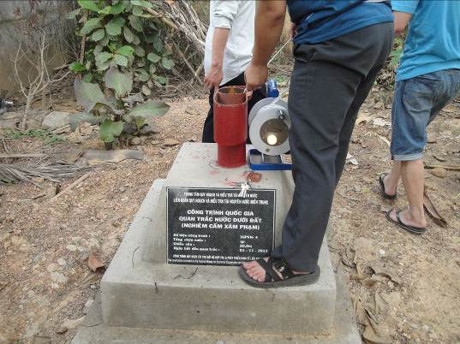
Fig.1: Measuring static water level at station IGPVN-4
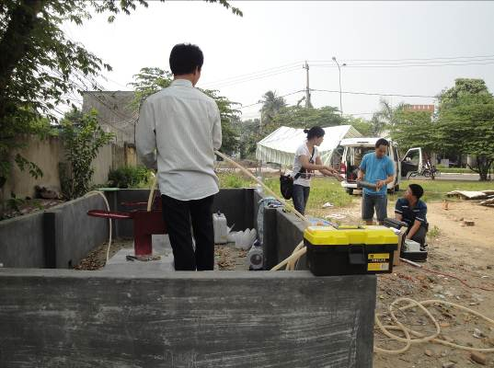
Fig.2: Installing submersible pump MP1
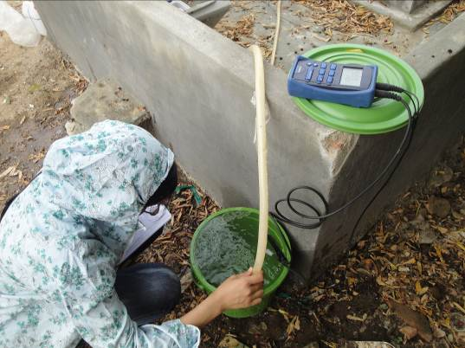
Fig. 3: Measuring the flow rate and in-situ parameters at the station IGPVN-6
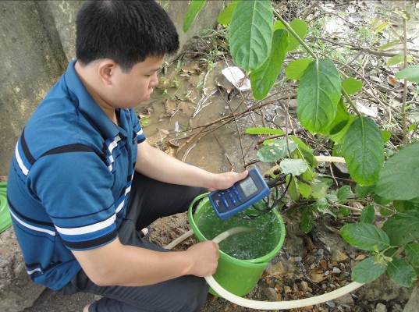
Fig. 4: Measuring in-situ parameters at the station IGPVN-8

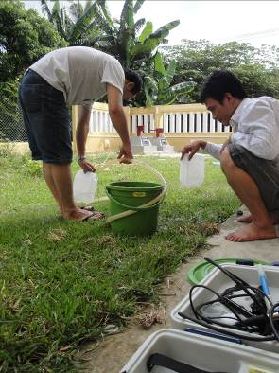 | 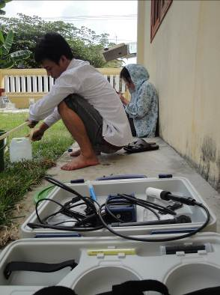
Fig. 5: Collecting groundwater samples at station IGPVN-9

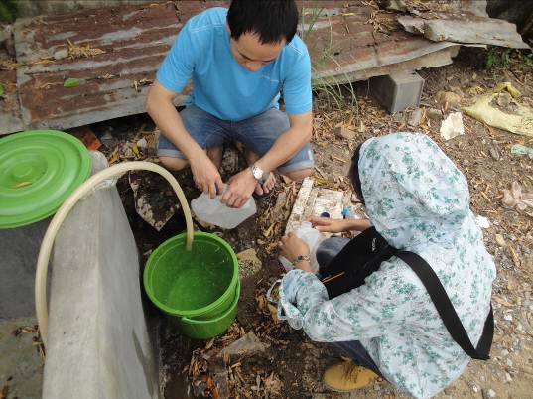
Fig. 6: Collecting groundwater samples at station IGPVN-6
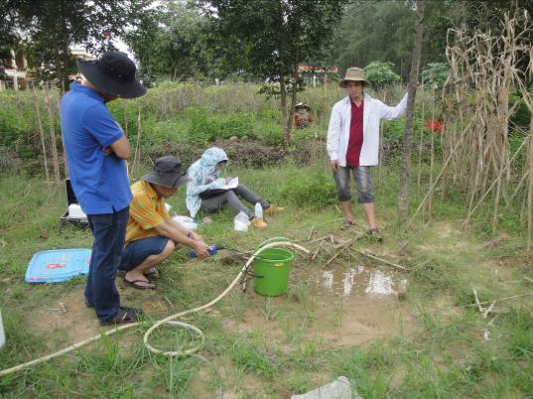
Fig. 7: Measuring and recording in-situ parameters at station IGPVN-2
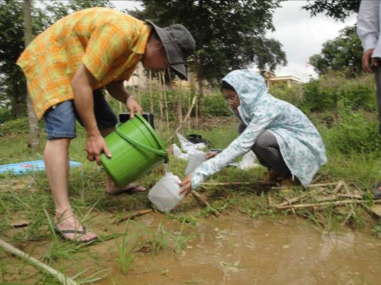
Fig. 8: Collecting groundwater samples at station IGPVN-2

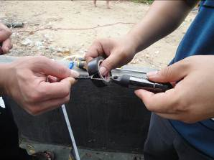 | 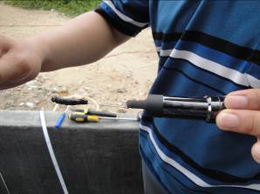
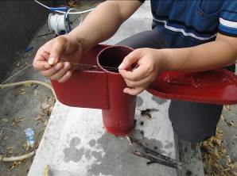 | 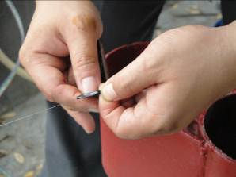
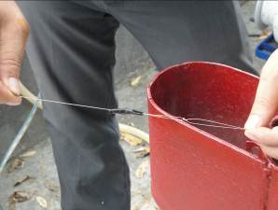 | 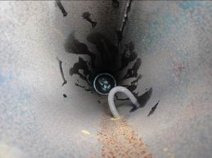
Fig. 9: Preparing the diver and cable and dropping into the well

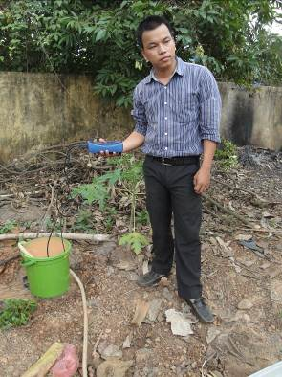 | 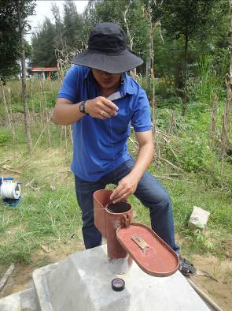
Fig. 10: Staff from Quang Ngai DONRE took part in the sampling field trip: measuring in-situ parameters (L) and dropping the diver into the well (R)

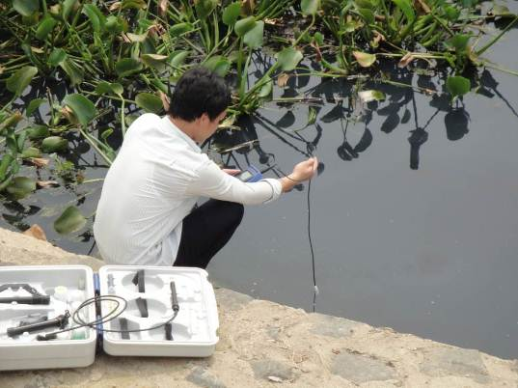
Fig. 11: Measuring in-situ parameters at wastewater lake
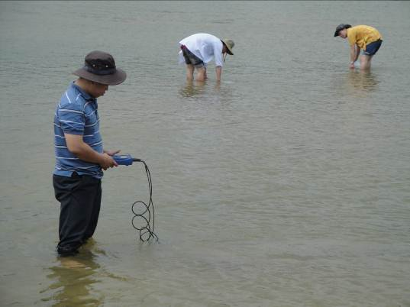
Fig. 12: Measuring in-situ parameters and collecting sample from Ve river
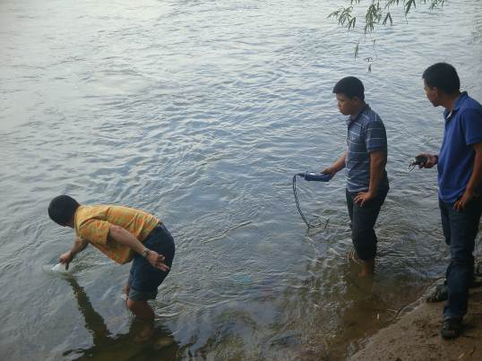
Fig. 13: Measuring in-situ parameters and collecting sample from Ve river

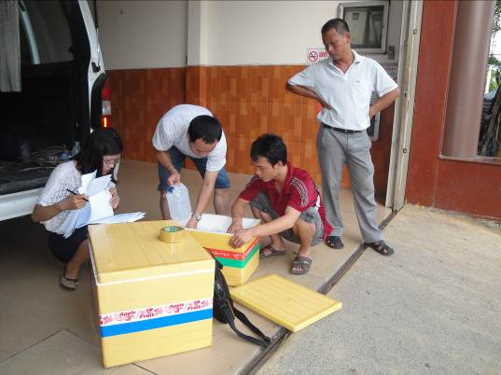
Fig. 14: Checking and rearranging samples before sending to the lab
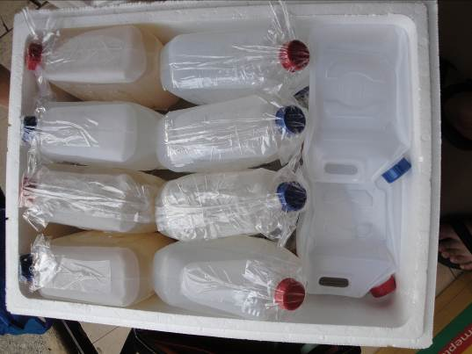
Fig. 15: Water samples stored in the box for transportation

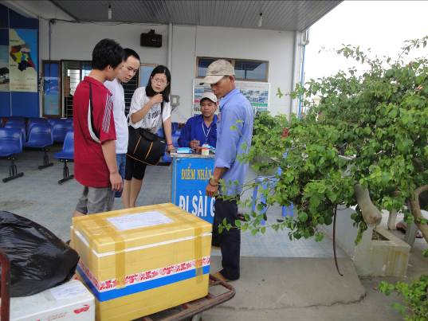
Fig. 16: Sending sample box at the bus station

