Progress Report
about the

8th IGPVN Training Course

Introduction to Hydrogeochemistry: Theoretical background, Field method and Data processing

Hoang Thi Hanh

Nha Trang, 16-17.10.2012, CEVIWRPI

Table of Content
Abbreviation 0
1. Outline of Training course 1
2. Training course objectives 1
3. Training course progress 2
3.1. Opening remark for the training course 2
3.2. Training course progress 2
3.3. Closing of the training course 3
4. Conclusion 3

Abbreviation
CWRPI | Center for Water Resources Planning and Investigation
CWRMF | Center for Water Resources Monitoring and Forecast
CWRQ | Center for Water Resources Quality
CWRDI | Center for Water Resources Data and Information
CWRPICS | Center for Water Resources Planning and Investigation Consultancy and Services
CEVIWRPI | Central Vietnam Division for Water Resources Planning and Investigation
IGPVN | Improvement of Groundwater Protection in Vietnam

Outline of Training course
Date: 16th - 17th October 2012
Trainer: Dr. Hoang Thi Hanh, supported by Hoang Dai Phuc
Participants: 15 staffs from CEVIWRPI, 2 staffs from Quang Ngai DONRE, 2 staffs from CWRPI
Dr. Do Tien Hung, Director of CWRPI
Dr. Nguyen Luu, Head of CEVIWRPI
Dr. Ho Minh Tho, Vice Head of CEVIWRPI

Training course objectives
The 1st Hydrogeochemistry training course was organized by IGPVN project in Hanoi for the staffs of CWRPI Headquarter, CWRMF, CWQ, CWRDI and CWRPIS. The 2nd Hydrogeochemistry training course was offered to the staffs of CEVIWRPI in Nha Trang.
The objectives of this training course were
- to affirm and improve the understanding of the learners on some specific issues relating to hydrogeochemical study:
- Basic concepts in hydrogeochemistry: pH, oxidizing-reducing potential, specific electrical conductivity, salinity, dissolved oxygen, alkalinity, turbidiy
- Chemical composition of natural water
- Processes controlling groundwater chemistry
- The relationship between water quality and human health
2) to make clear to the learners about the field works, sampling, sample preservation and analysis; to provide the learners a chance to practise with the WTW equipments: measure pH, conductivity values and dissolved oxygen content of some water samples and calibrate the equipment using the appropriate standard solutions
3) to help the learners learn about data processing in hydrogeochemistry so that they can assess the reliability of a given data set, create appropriate graphs to display the data and prepare a brief report to summarize and comment on the data

Training course progress
  - Opening remarks for the training course
At first, Dr. Ho Minh Tho introduced all the participants attending the training course and informed all the participants about the training course organized by IGPVN project: main content and instructor. Then, Dr. Do Tien Hung gave a brief speech on the tasks and goals of the IGPVN project and the purpose of the training course.
  - Training course progress
The two-day training course on Hydrogeochemical study was prepared by Dr. Hoang Thi Hanh (IGPVN) on 16th and 17th, October, 2012 at CEVIWRPI in Nha Trang city, Khanh Hoa province. Staffs from different departments of CEVIWRPI and from Quang Ngai DONRE were invited to the training course. Three main parts were prepared and presented throughout the training course.
Details are as follows:
Theoretical background
A number of basic concepts on hydrogeochemistry including pH, redox potential, electrical conductivity, salinity, dissolved oxygen, alkalinity, turbidity; clarify the meaning of each concept, the measuring unit, influencing factors and measuring equipments were summarized and presented to the learners. The chemical composition of groundwater was explained and important processes that can control groundwater chemistry (adsorption/desorption, ion exchange, oxidation-reduction, carbonate diagenesis, silicate dissolution) were briefly presented. The relation between water and human health was also mentioned together with the drinking water guideline.
Field methods
The basic steps on preparation for a field trip, on-site protocol, sample preservation and sample analysis in laboratory were explained to the learners: how to prepare for a field trip, what to do in the field to collect water samples, which parameters should be measured on-site, how to preserve water samples for chemical analysis and what kind of analytical instruments can be used for determination of various components in natural water.
Then Mr. Phuc introduced to the learners about the WTW box: which parameters can be measured using WTW box, how it works and how to calibrate the equipment before using. The participants were able to practise with the WTW box: measure pH, conductivity values and dissolved oxygen concentration of some water samples and calibrate the equipment using the appropriate standard solutions.
At the end of the 1st day, a list of multiple-choice questions relating to the theoretical background and field method was given to each learner.
Data processing
During this session, Dr. Hanh introduced to the learners about the sources of hydrogeochemical data, why these data need to be processed. Some techniques on data processing were explained to the learners and they knew how to calculate the charge balance error and what can be inferred from this calculation. A number of typical graphs used in hydrogeochemical study (Piper diagram, Stiff diagram and Schoeller diagram) were introduced in detail to the learners. They also learned about many other graphs (histogram, bar chart, box plot, scatter plot, time series) that were very helpful in display and visualization of the hydrogeochemical data. They installed and practised with SigmaPlot 10.0, an effective software that can create many different types of graphs as well as perform some basic statistic calculation.
In the final practical session, a raw data set on groundwater chemical analysis was provided to the learners so that each of them can process the data, summarize the data and make some comments on that data set in a brief summary with respect to data reliability, groundwater quality, hydrogeochemical characteristic of groundwater.
  - Closing of the training course
At the end of the second training day when the learners finished their practical assignment, Dr. Do Tien Hung gave closing remarks on behalf of CWRPI and IGPVN project. He emphasized that capacity building and training-on-trainer are very important and necessary to the staffs of CEVIWRPI; the training course organized by IGPVN project provided good chance for them to improve their knowledge and expertise. Dr. Nguyen Luu on behalf of the CEVIWRPI thanks the IGPVN project for organizing the training course and suggested IGPVN project to provide them more equipment for in-situ parameter measurement.

Feedback about the training

According to the learners, the Hydrogeochemical training course provided them generally very useful knowledge and practice. They had good chance to practice with the WTW box, measure some water parameters and calibrate the equipment.
The learners suggested that the content of the training course should be prepared in Vietnamese to help they learn more effectively due to their limited English proficiency. The time allowance for the training course should be increased to about 3 days or more so that the learners can easily catch up with the training contents.
They expected the next training course organized by IGPVN project would be about calculation and interpretation of the hydrogeological parameters.

Conclusion
During the two-day training course, the participants had good time to learn about new issue as well as review what they had learnt before. Moreover, they had good chance to practice with the measuring equipment and practice with data analysis. It is recommended that the content of the future training course should be prepared in Vietnamese and time training time should be longer.

Annex 1: Pictures of the training course
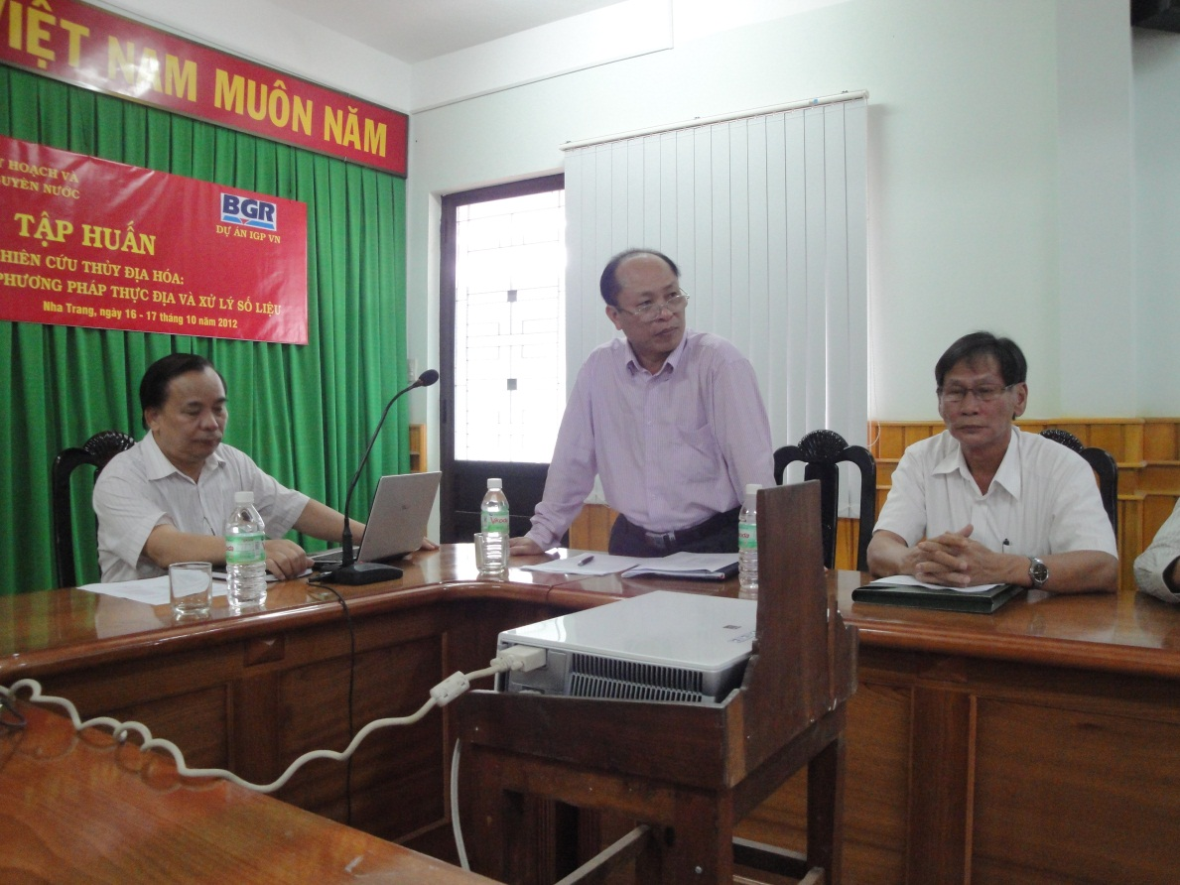
Fig. 1: Dr. Do Tien Hung, Dr. Nguyen Luu and Dr. Ho Minh Tho at the Opening Remarks of the Training course

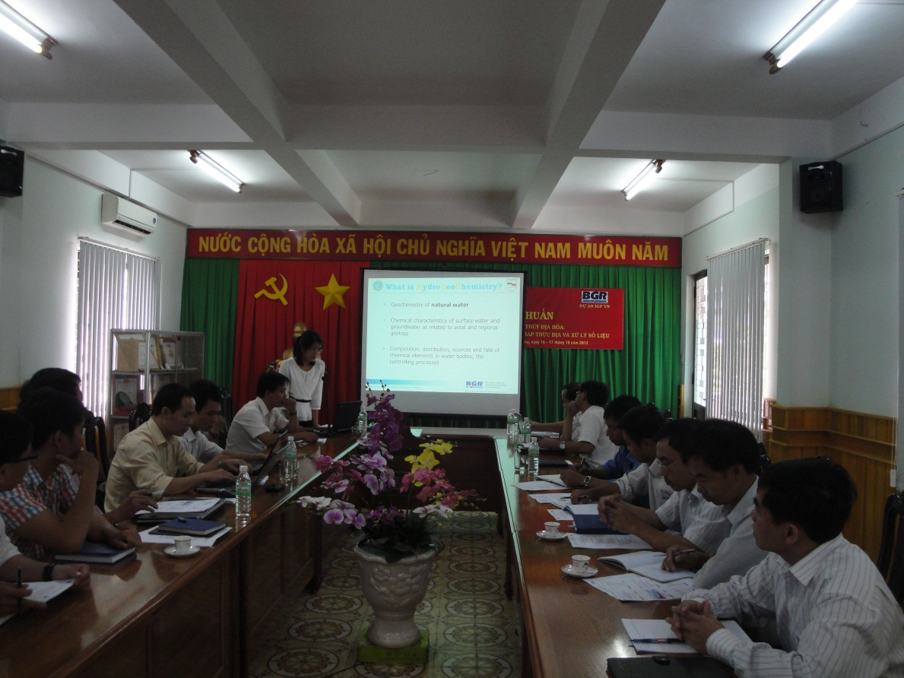
Fig. 2: Giving lecture on the theoretical background of Hydrogeochemistry

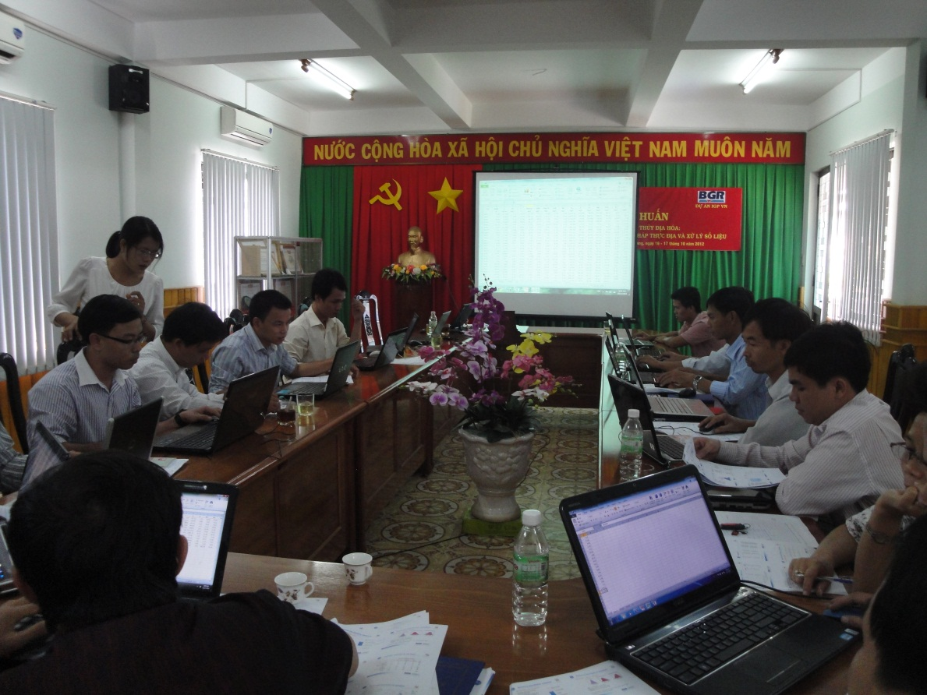
Fig.3: Calculating the Charge Balance Error for a given data set

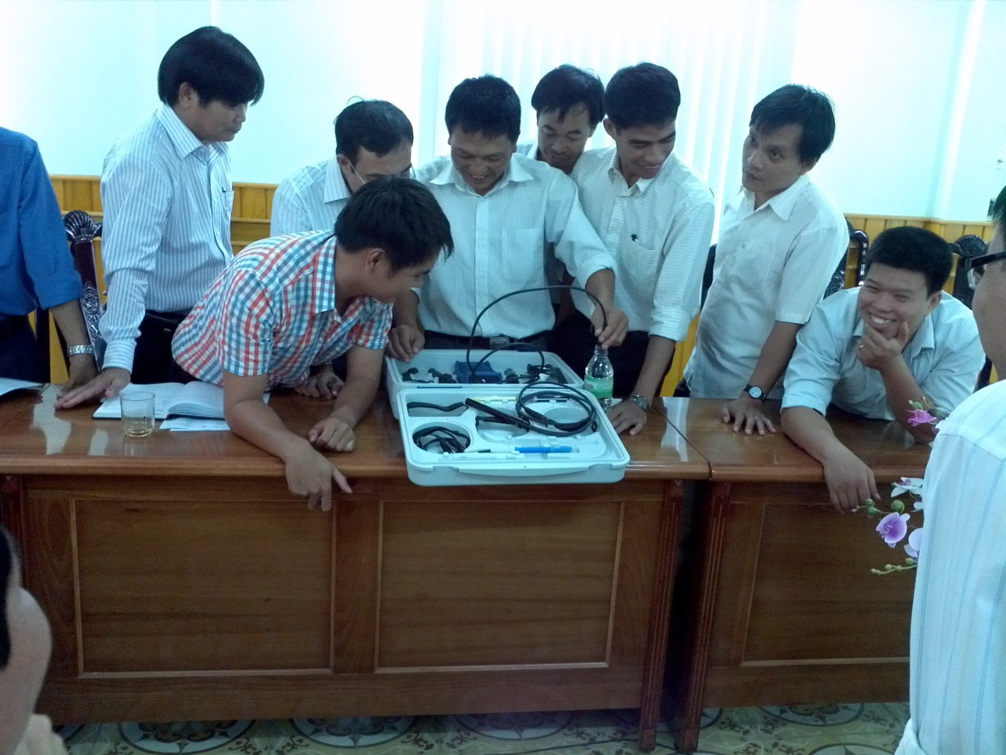
Fig. 4: Practising with the WTW box

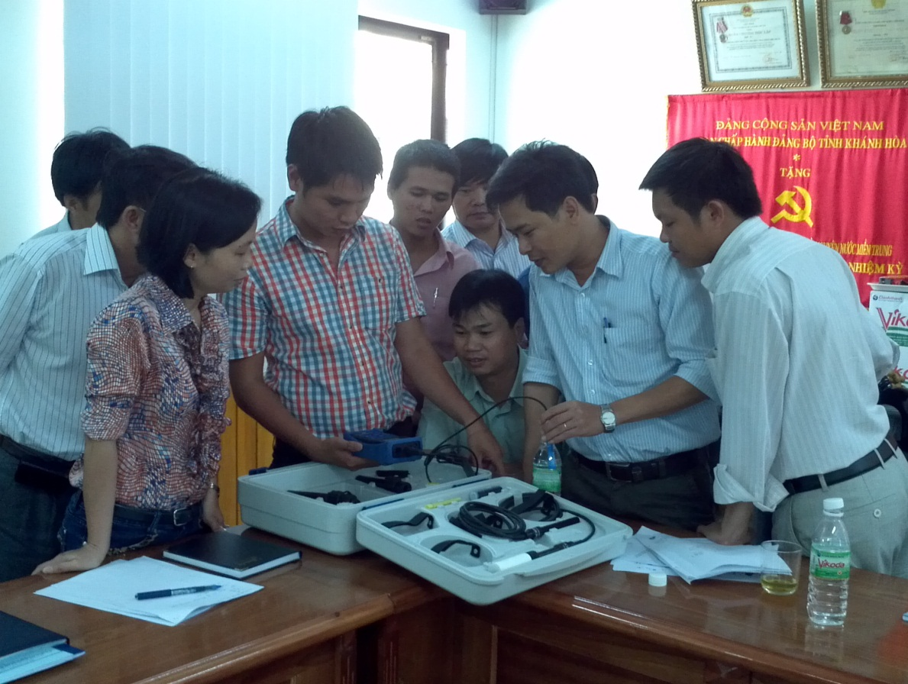
Fig.5: Practising with the WTW box

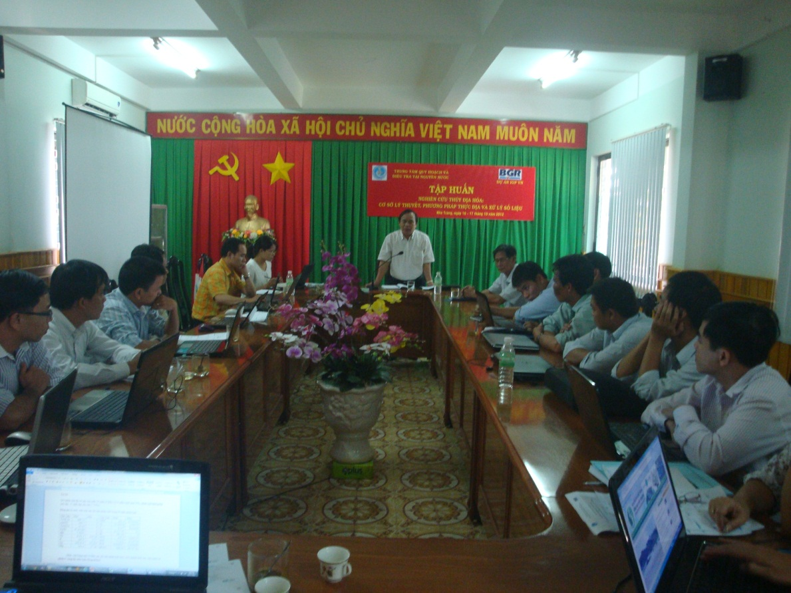
Fig.6: Dr. Do Tien Hung gave Closing Remarks for the training course

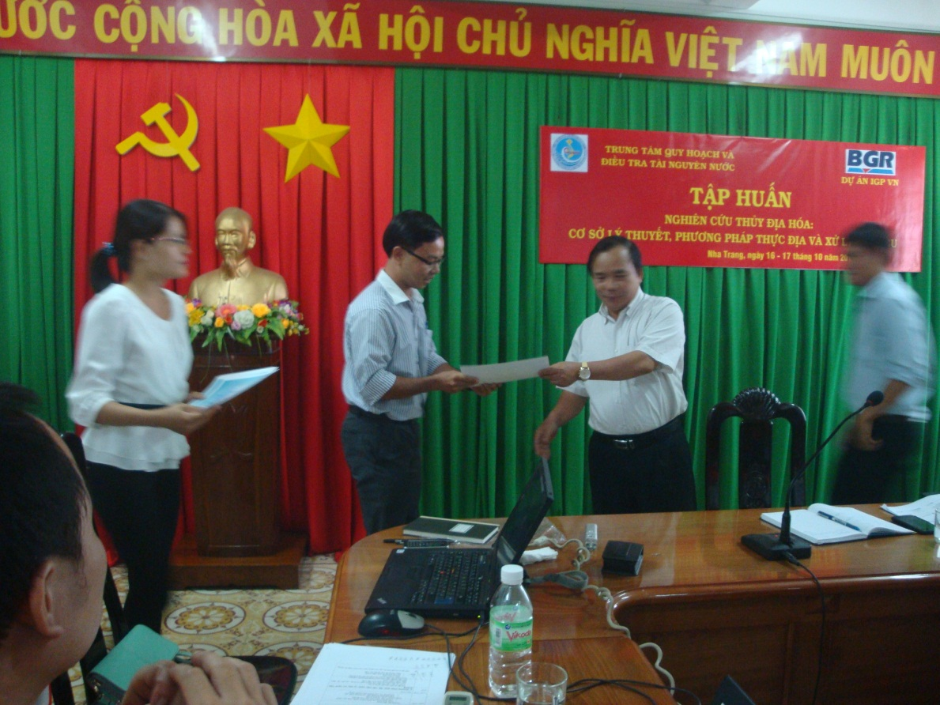
Fig.7: Dr. Do Tien Dung awarded the certificates to the learners

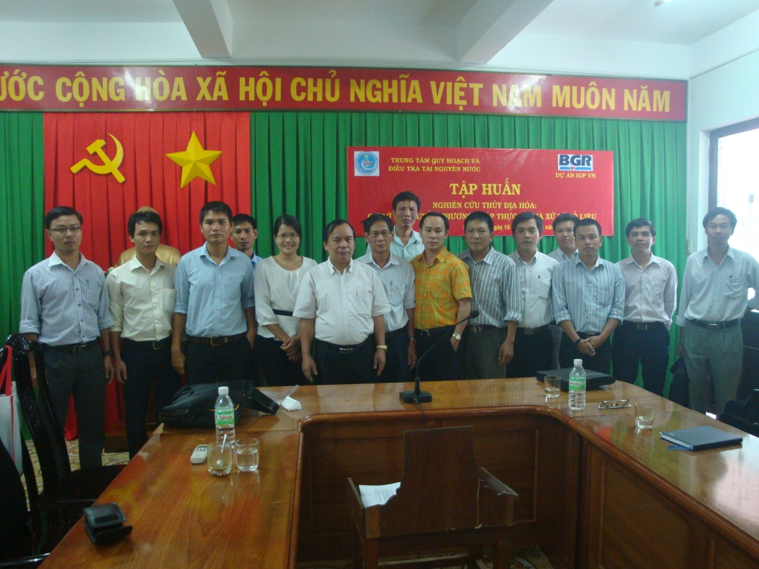
Fig. 8: Staffs from CEVIWRPI and Quang Ngai DONRE attending the Hydrogeochemistry training course organized by IGPVN project

